**2-Sep-2024**

**Internship Day - 32 Report:**

**CCNA (Cisco Certified Network Associate)**

**What is Network?**

A computer network can be described as a system of interconnected devices that can communicate using some common standards called the Internet protocol suite or TCP/IP. These devices communicate to exchange network resources, such as files and printers, and network services.

**Types of Computer Networks**

Listed below are the most common types of computer networks:

1. **Local Area Network (LAN)** – LANs are commonly used in small to medium size companies, households, buildings, etc., with limited space.
2. **Personal Area Network (PAN)** – PAN covers a short distance of 10 meters. Bluetooth is an example of PAN.
3. **Metropolitan Area Network (MAN)** – MANs are used in a single geographic region, such as a city or town.
4. **Wide Area Network (WAN)** – WANs cover larger areas like different states and countries.
5. **Wireless Local Area Network (WLAN)** – Wireless LAN is used for wireless networks, connecting wired and wireless devices.

**LAB 1: ONE ROUTER ONE SWITCH THREE PC**

**ROUTER:** A router is a networking device that directs data packets between different networks, such as between a local home network (LAN) and the internet (WAN).

Routers can also assign IP addresses, manage traffic within a network, routers help devices communicate across different networks efficiently and securely.

**SWITCH:** A switch is a networking device that connects multiple devices within a local area network (LAN) and directs data to the specific device using MAC addresses.

**PC:**  A PC (Personal Computer) is a general-purpose computing device designed for individual use. It typically consists of hardware like a central processing unit (CPU), memory (RAM), storage (hard drive or SSD), and input/output devices (keyboard, mouse, monitor). PCs run operating systems like Windows, macOS, or Linux, allowing users to perform tasks such as browsing the internet, running software applications, and storing data.

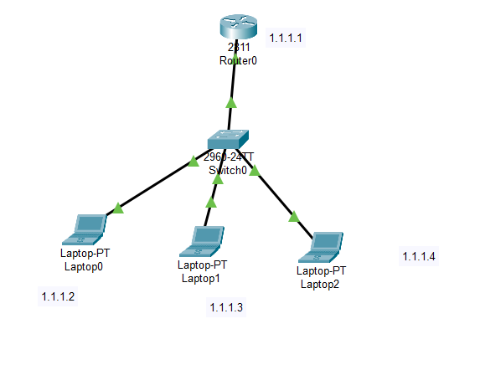

**Step 1: Open Cisco Packet Tracer**

Launch Cisco Packet Tracer on your computer.

**Step 2: Add Devices**

**1. Router:**

In the left sidebar, click on the Router icon (the router icon) and drag a router (e.g., Cisco 2901) onto the workspace.

**2. Switch:**

In the same sidebar, click on the Switch icon and drag a Switch 2960 or any other model) onto the workspace.

**3. PCs:**

Click on the End Devices icon (the computer icon) and drag 3 PCs onto the workspace.

**Step 3: Connect Devices**

**1. Router to Switch:**

* Click on the Connections icon (the lightning bolt) in the lower-left corner of Packet Tracer.
* Choose the Copper Straight-Through Cable. (This cable is used for different devices.)
* Connect one end of the cable to any Ethernet port on the router
* (FastEthernet0/0) and the other end to any port on the switch
* (FastEthernet0/1).

**2. PCs to Switch:**

Use the Copper Straight-Through Cable again to connect each PC to the switch.

**For example:**

* PC1 to FastEthernet0/2 on the switch.
* PC2 to FastEthernet0/3.
* PC3 to FastEthernet0/4.

**Step 4: Assign IP Addresses to PCs**

1. Click on PCs one by one.

2. Go to the Desktop tab and select IP Configuration.

3. Assign an IP address with a subnet mask:

* + PC1: IP 1.1.1.2, SUBNET MASK: 255.0.0.0
  + PC2: IP 1.1.1.3, SUBNET MASK: 255.0.0.0
  + PC3: IP 1.1.1.4, SUBNET MASK: 255.0.0.0

**Step 5: Configure the Router (Optional for Routing)**

If you want to add routing to the router (for example, to enable the router to communicate with the PCs), follow these steps:

**1. Click on the Router and go to the CLI tab.**

**2. Enter the following commands to set up the router:**

* **Router> enable**: The enable command is used to move from **user EXEC mode** to **privileged EXEC mode** on a Cisco router or switch.
* **Router# configure terminal**: This command allows you to enter global configuration mode on a Cisco router or switch.
* **Router(config)# interface fa0/0**: This command selects the **Fast Ethernet 0/0** interface for configuration. It allows you to configure settings like IP addresses, interface status, and other parameters specific to this interface.
* **Router(config-if) # Ip address 1.1.1.1 255.0.0.0**: Ip address: This command is used to configure the IP address and subnet mask for an interface.
* 1.1.1.1: This is the **IP address** that you're assigning to the interface. In this case, the address.
* 1.1.1.1 is part of the **Class A** address space, which traditionally uses a 255.0.0.0 subnet mask.
* **Router(config-if) # no shutdown**: This command **enables** the interface, bringing it out of the **shutdown** state and allowing it to begin functioning and passing traffic.
* **shutdown** is a command used to **disable** the interface, and when you use **no shutdown**, you're effectively reversing that action and enabling the interface.
* **Router(config-if) # exit**: it is used to **exit** the **interface configuration mode** and return to **global configuration mode**
* **Router(config)# exit**: it is used to **exit global configuration mode** and return to **privileged EXEC mode** on a Cisco router or switch.

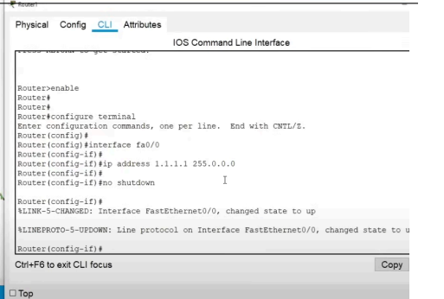

**Step 6: Verify Connectivity (Ping Test)**

1. On each PC, open the Command Prompt from the Desktop tab.

2. Run a ping test to check the network connectivity:

* + From PC1, ping `1.1.1.1` (the router’s IP address).
  + From PC2 and PC3, ping the other PCs (e.g., `ping 1.1.1.3`, `1.1.1.4`).  
      
    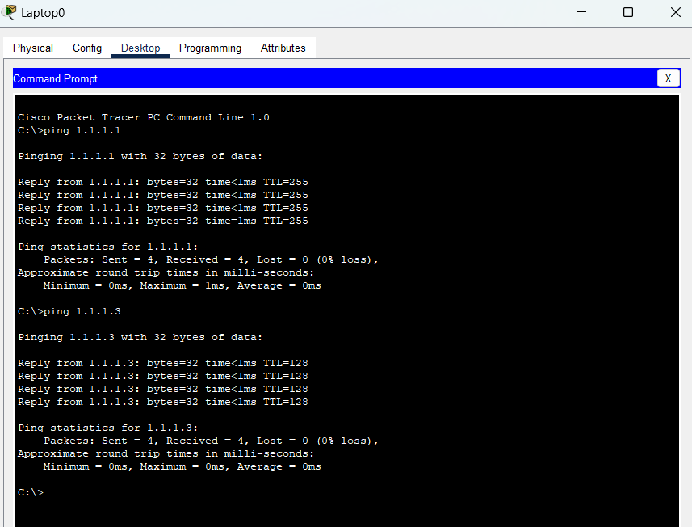
* This setup enables basic connectivity between PCs through the switch and router, allowing for communication within the same network.

**How To Save Router Configuration commands:**

* **Router# show running-config**
* **Router# copy running-config startup-config**
* **How To Remove Router & Interface Configuration:**
* **Router# erase startup-config**
* **Router # reload:**  The router will prompt to save the current running configuration before reloading. Since you’ve erased the startup config and want to remove the configuration.

**2-Sep-2024**

**Internship Day - 33 Report:**

**Physically Perform In Lab**

**04-Sep-2024**

**Internship Day - 34 Report:**

**LAB 2: STATIC ROUTING**

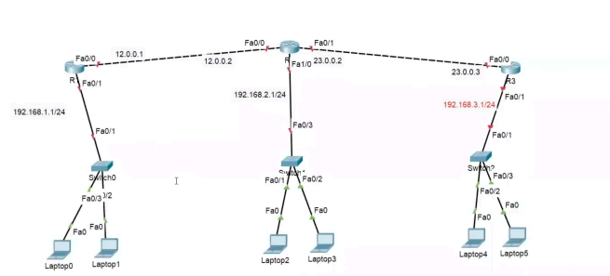

To implement static routing as shown in the diagram, follow these steps:

**1. Identify Networks:**

* Network 1: 192.168.1.0/24 (connected to Router R1)
* Network 2: 192.168.2.0/24 (connected to Router R2)
* Network 3: 192.168.3.0/24 (connected to Router R3)
* **WAN Links:**
* Link between R1 and R2: 12.0.0.0/24
* Link between R2 and R3: 23.0.0.0/24

**2. Configuring Static Routes: (Always give networked)**

**1) On Router R1:**

* **Configure the default route to reach network 192.168.2.0/24 and 192.168.3.0/24 via R2:bash**
* ip route 192.168.2.0 255.255.255.0 12.0.0.2
* ip route 192.168.3.0 255.255.255.0 12.0.0.2

2) **On Router R2:**

* **Configure routes to reach 192.168.1.0/24 via R1 and 192.168.3.0/24 via R3:bash**
* ip route 192.168.1.0 255.255.255.0 12.0.0.1
* ip route 192.168.3.0 255.255.255.0 23.0.0.2

**3) On Router R3:**

* **Configure the route to reach network 192.168.1.0/24 and 192.168.2.0/24 via R2:bash**
* ip route 192.168.1.0 255.255.255.0 23.0.0.1
* ip route 192.168.2.0 255.255.255.0 23.0.0.1

**3. Configure Interfaces: You need to assign the correct IP addresses to the interfaces on each router as per the diagram:**

**On Router R1:**

* interface Fa0/0
* ip address 12.0.0.1 255.255.255.0
* no shutdown
* interface Fa0/1
* ip address 192.168.1.1 255.255.255.0
* no shutdown

**On Router R2:**

* interface Fa0/0
* ip address 12.0.0.2 255.255.255.0
* no shutdown
* interface Fa0/1
* ip address 23.0.0.1 255.255.255.0
* no shutdown
* interface Fa0/3
* ip address 192.168.2.1 255.255.255.0
* no shutdown

**On Router R3:**

* interface Fa0/0
* ip address 23.0.0.2 255.255.255.0
* no shutdown
* interface Fa0/1
* ip address 192.168.3.1 255.255.255.0
* no shutdown

**The commands you mentioned are used to configure static routes on Router R1. Here's a detailed explanation of each command:**

* **ip route 192.168.2.0 255.255.255.0 12.0.0.2**
* **ip route:** This is the command used to create a static route.
* **192.168.2.0:** This is the destination network that Router R1 needs to send traffic to (Network 2 in the diagram).
* **255.255.255.0:** This is the subnet mask for the destination network, indicating that it's a /24 network.
* **12.0.0.2:** This is the next-hop IP address, which is the IP address of the interface on Router R2 (the router directly connected to R1 on the 12.0.0.0/24 network).

**This command tells Router R1 that to reach the 192.168.2.0/24 network (connected to Router R2), it should forward the traffic to 12.0.0.2 (Router R2).**

* **ip route 192.168.3.0 255.255.255.0 12.0.0.2**
* **ip route:** Again, this is the command to add a static route.
* **192.168.3.0:** This is the destination network that Router R1 needs to send traffic to (Network 3 in the diagram).
* **255.255.255.0:** This is the subnet mask for the destination network, indicating it's a /24 network.
* **12.0.0.2:** This is the next-hop IP address, which is Router R2's interface in the 12.0.0.0/24 network.

This command tells Router R1 that to reach the 192.168.3.0/24 network (connected to Router R3), it should forward the traffic to 12.0.0.2 (Router R2).

Router R2 will then forward the traffic to Router R3.

192.168.2.0/24 (its own local network) and 192.168.3.0/24 (via Router R3).

**Key Concepts:**

* Next hop is typically the IP address of a router interface directly connected to the current router.
* A router doesn't need to know the entire path to the destination, just the IP address of the next device (next hop) that is part of the route toward the destination.

**Example:**

In your previous configuration:

* **ip route 192.168.2.0 255.255.255.0 12.0.0.2**
* Destination Network: 192.168.2.0/24 (Network 2, located behind Router R2).
* Next-Hop IP: 12.0.0.2 (This is the IP address of Router R2’s interface that is directly connected to Router R1).
* So, when Router R1 needs to send packets to the 192.168.2.0/24 network, it forwards those packets to 12.0.0.2 (the next-hop address). Router R2 then takes over and
* forwards the packet to the correct destination.

**Visualizing the Next-Hop:**

1. If Router R1 wants to send traffic to a destination that is not directly connected to it, it forwards the packet to the next-hop router (Router R2), which is responsible for forwarding the packet further down the network path.
2. This concept is essential in static routing (where routes are manually defined) as well as in dynamic routing protocols (where routers learn paths to destinations automatically).

**05-Sep-2024**

**Internship Day - 35 Report:**

**LAB 3: DYANMIC ROUTING USING RIP**

To configure RIP v2 (Routing Information Protocol version 2) for the network topology shown in the image, you can follow these steps for each router in your

network.

**Step 1: Access Each Router's Configuration Mode**

Connect to each router and enter the global configuration mode:

Router> enable

Router# configure terminal

**Step 2: Enable RIP v2 on Each Router**

For each router (R1, R2, and R3), you need to enable RIP and specify the networks that will participate in RIP.

**Configuration for R1:**

* R1(config)# router rip
* R1(config-router)# version 2
* R1(config-router)# no auto-summary
* R1(config-router)# network 12.0.0.0
* R1(config-router)# network 192.168.1.0
* R1(config-router)# exit

**Configuration for R2:**

* R2(config)# router rip
* R2(config-router)# version 2
* R2(config-router)# no auto-summary
* R2(config-router)# network 12.0.0.0
* R2(config-router)# network 23.0.0.0
* R2(config-router)# network 192.168.2.0
* R2(config-router)# exit

**Configuration for R3:**

* R3(config)# router rip
* R3(config-router)# version 2
* R3(config-router)# no auto-summary
* R3(config-router)# network 23.0.0.0
* R3(config-router)# network 192.168.3.0
* R3(config-router)# exit

**Step 3: Save the Configuration**

After configuring RIP on all routers, save the configuration to ensure it persists after a reboot.

**Router# write memory**

**Step 4: Verify the Configuration**

You can verify that RIP is working and that the routers are exchanging routing information with the following commands:

**Router# show ip route**

**Router# show ip protocols**

**Explanation of the Configuration:**

* **version 2:** Specifies that the router should use RIP version 2.
* **no auto-summary:** Disables automatic summarization of networks, allowing RIP to advertise subnet information.
* **network [network-address]:** Specifies the networks that will be included in the RIP routing process.

By following these steps on all routers in the network, RIP v2 will be set up, allowing the routers to share routing information dynamically. Each router will learn about other networks connected through the other routers and route traffic accordingly

**6-Sep-2024**

**Internship Day-36 Report:**

**OSPF (Open Shortest Path First):**

**1. Scalability:** OSPF is more scalable and suitable for larger networks compared to RIP. It’s widely used in real-world networks.

**2. Link-State Protocol:** OSPF uses a link-state routing algorithm, which can give you a deeper understanding of how routing decisions are made compared to the distance-vector approach of RIP.

**3. Widely Applicable:** Knowledge of OSPF is often required for network certifications and is valuable for understanding many enterprise network environments.

Once you’re comfortable with OSPF, you might then explore EIGRP to understand Cisco’s advanced routing protocol, and eventually move on to BGP for a broader perspective on internet-scale routing.

**When it’s said that knowledge of OSPF is often required for network certifications and is valuable for understanding many enterprise network environments, it means:**

**1. Network Certifications:** OSPF is frequently covered in networking certification exams, such as the Cisco CCNA (Cisco Certified Network Associate) and CCNP (Cisco Certified Network Professional) exams. These certifications are often pursued by IT professionals to validate their skills and knowledge in network management and routing.

**2. Enterprise Networks:** Many businesses and organisations use OSPF in their internal network infrastructure due to its efficiency and scalability. Understanding OSPF helps in managing and troubleshooting these networks effectively.

In summary, OSPF is a key concept in both professional certifications and real-world network management, making it a crucial area of knowledge for anyone pursuing a career in networking.

**What is link-state routing algorithm?**

Link-State Routing Algorithm

**Definition:** A link-state routing algorithm is a type of routing protocol that builds a complete map of the network by gathering information about the state of each network link. Each router in the network uses this map to compute the best path to each destination.

**Key Concepts:**

**1. Network Map:** Each router creates a link-state database (LSDB) that contains information about the network topology, including the state of all links (e.g., up or down) and the cost associated with each link.

2**. Link-State Advertisements (LSAs):** Routers periodically send out link-state advertisements to inform other routers about the state of their links. This information is used to update the LSDB.

**3. Dijkstra’s Algorithm:** Once each router has a complete map of the network, it uses Dijkstra’s Shortest Path First (SPF) algorithm to calculate the shortest path to each destination based on the link costs.

**4. Convergence:** Link-state protocols generally converge faster than distance-vector protocols because routers update their LSDBs immediately when there is a change in the network, leading to a quicker recalculation of routes.

**Advantages:**

1. **Scalability:** Suitable for larger networks due to its efficient use of network resources and faster convergence.
2. **Accuracy:** Provides a more accurate view of the network topology compared to distance-vector protocols.
3. **Reduced Routing Loops:** Because each router has a complete view of the network, routing loops are less likely.

**Example Protocols:** OSPF (Open Shortest Path First) and IS-IS (Intermediate System to Intermediate System) are common examples of link-state routing protocols.

In summary, link-state routing algorithms help routers understand the entire network topology and calculate optimal routing paths, leading to more efficient and reliable network operation.

**LAB 4: OSPF ROUTING**

**Step-by-Step OSPF Configuration**

**1. Configure OSPF on Router0 (Chandigarh)**

1. **Enter global configuration mode:**

Router0> enable

Router0# configure terminal

1. **Start the OSPF process and assign an OSPF process ID (we'll use 1):**

Router0(config)# router ospf 1

**3. Assign networks to OSPF area 1:**

* **Fa0/0 (192.168.1.0/24)**
* **Fa1/0 (10.1.1.0/30)**
* **Fa0/2 (23.1.2.0/30)**

Router0(config-router)# network 192.168.1.0 0.0.0.255 area 1

Router0(config-router)# network 10.1.1.0 0.0.0.3 area 1

Router0(config-router)# network 23.1.2.0 0.0.0.3 area 1

1. **Exit OSPF configuration:**

Router0(config-router)# exit

**2. Configure OSPF on Router1 (Delhi)**

1. **Enter global configuration mode:**

Router1> enable

Router1# configure terminal

1. **Start the OSPF process:**

Router1(config)# router ospf 1

1. **Assign networks to OSPF area 1:**
   * **Fa0/0** (172.136.4.0/30)
   * **Fa0/1** (192.168.2.0/24)
   * **Fa0/2** (17.5.3.0/30)

Router1(config-router)# network 172.136.4.0 0.0.0.3 area 1

Router1(config-router)# network 192.168.2.0 0.0.0.255 area 1

Router1(config-router)# network 17.5.3.0 0.0.0.3 area 1

1. **Exit OSPF configuration:**

Router1(config-router)# exit

**3. Configure OSPF on Router2 (Kurukshetra)**

1. **Enter global configuration mode:**

Router2> enable

Router2# configure terminal

1. **Start the OSPF process:**

Router2(config)# router ospf 1

1. **Assign networks to OSPF area 1:**
   * **Fa0/0 (23.1.2.0/30)**
   * **Fa1/0 (17.5.3.0/30)**

Router2(config-router)# network 23.1.2.0 0.0.0.3 area 1

Router2(config-router)# network 17.5.3.0 0.0.0.3 area 1

1. **Exit OSPF configuration:**

Router2(config-router)# exit

**4. Configure OSPF on Router3 (Panipat)**

1. **Enter global configuration mode:**

Router3> enable

Router3# configure terminal

1. **Start the OSPF process:**

Router3(config)# router ospf 1

1. **Assign networks to OSPF area 1:**
   * **Fa0/0 (172.136.4.0/30)**
   * **Fa1/0 (10.1.1.0/30)**

Router3(config-router)# network 172.136.4.0 0.0.0.3 area 1

Router3(config-router)# network 10.1.1.0 0.0.0.3 area 1

1. **Exit OSPF configuration:**

Router3(config-router)# exit

**5. Verify OSPF Configuration**

On each router, use the following command to verify that OSPF is working and neighbors are established:

1. **Check OSPF neighbors:**

Router# show ip ospf neighbor

1. **Check the OSPF routing table:**

Router# show ip route ospf